# Installation of Tura 4.0.0

1. Download Eclipse Mars for Java developers.
2. Extract Eclipse from archive and launch it.
3. Navigate to Eclipse Marketplace

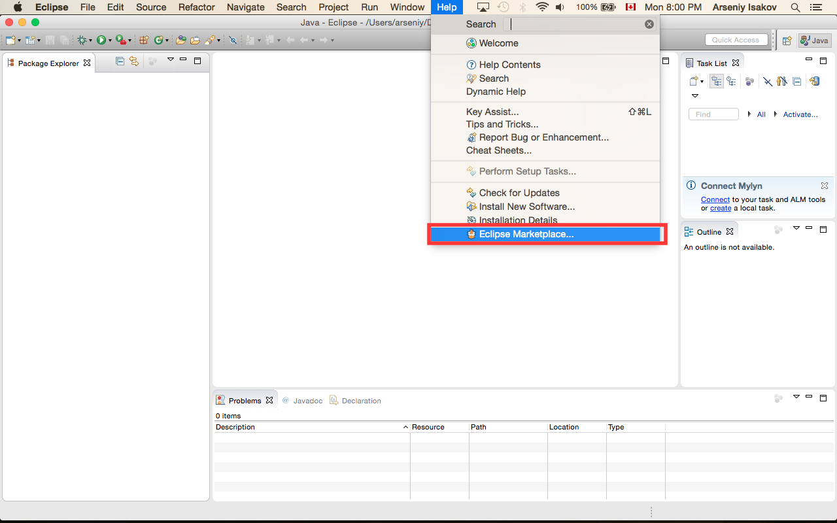

and find modeling framework Epsilon 1.2

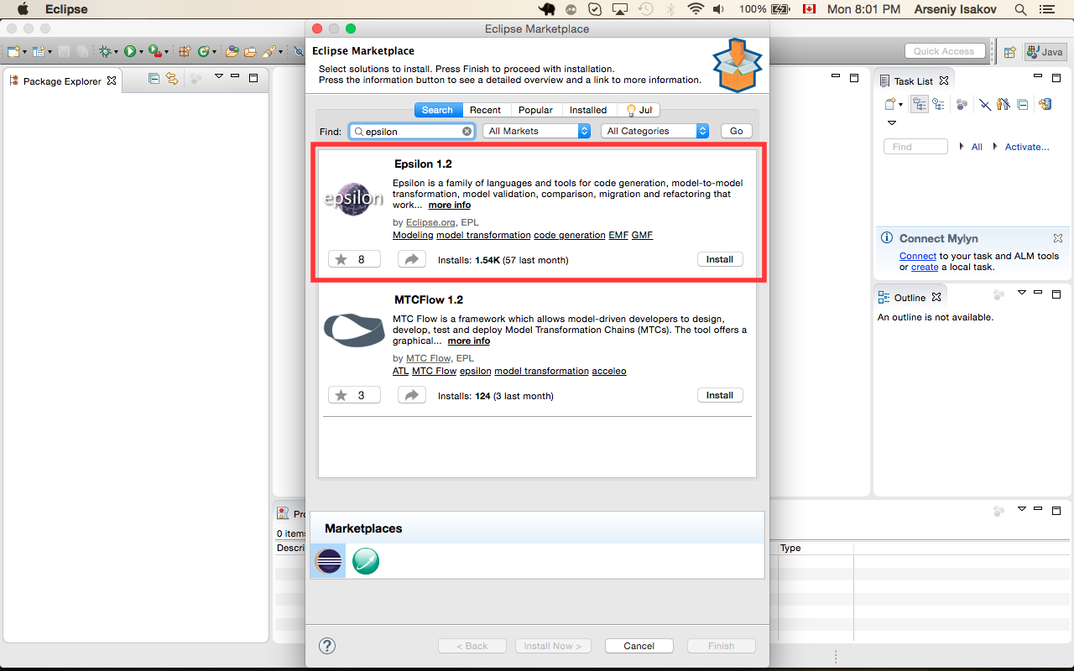

1. Install Epsilon 1.2
2. Download Tura framework from <http://sourceforge.net/projects/tura/files/>
3. Select “Install New Software” in Eclipse

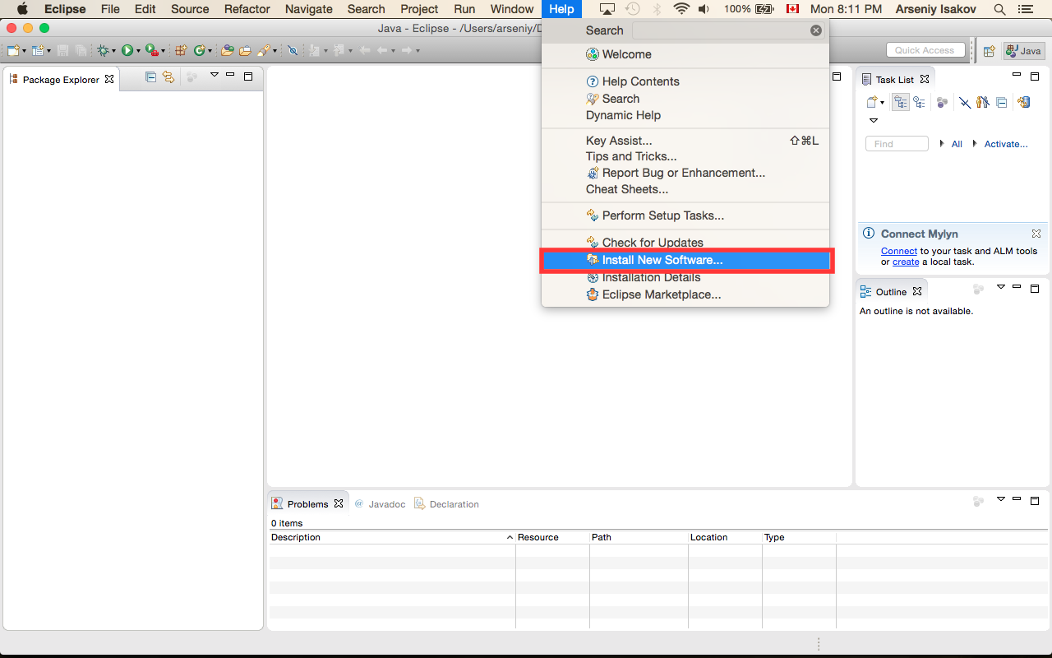

1. (1) – press “Add” button and select location of downloaded previously Tura archive

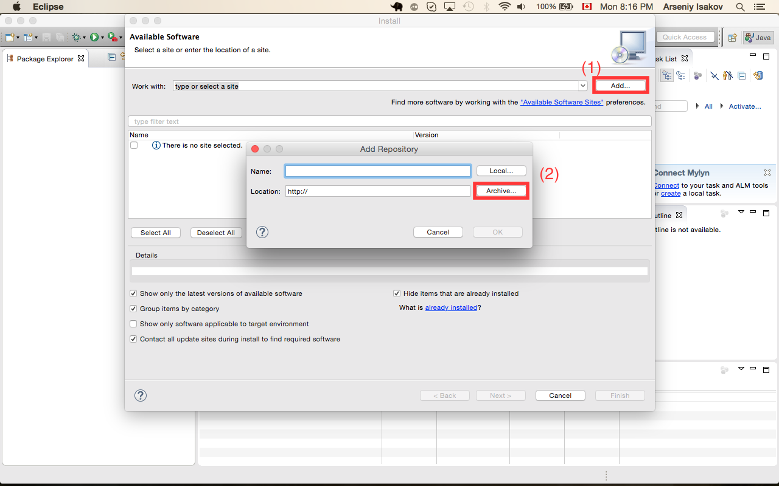

1. Select Tura application, press “Next” button and follow wizard flow

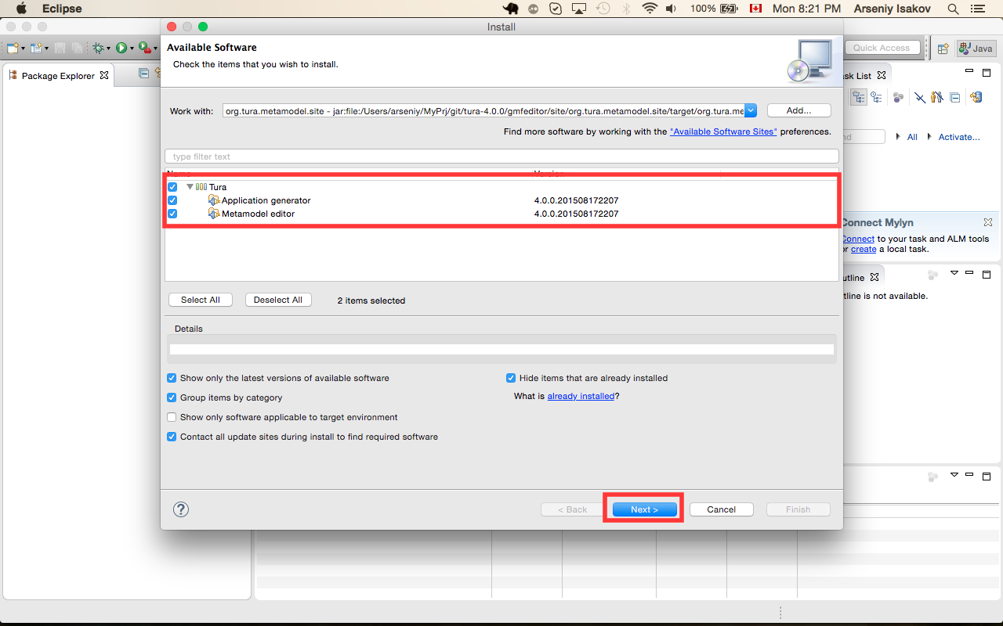

# DataBase configuration

1. Open <http://www.postgresql.org/download/> and select you platform and download postgresql database.
2. Install postgresql.
3. Download postgresql admin tool from <http://www.pgadmin.org/download/> and install it.
4. Run pgAdmin.
5. Configure connection to database

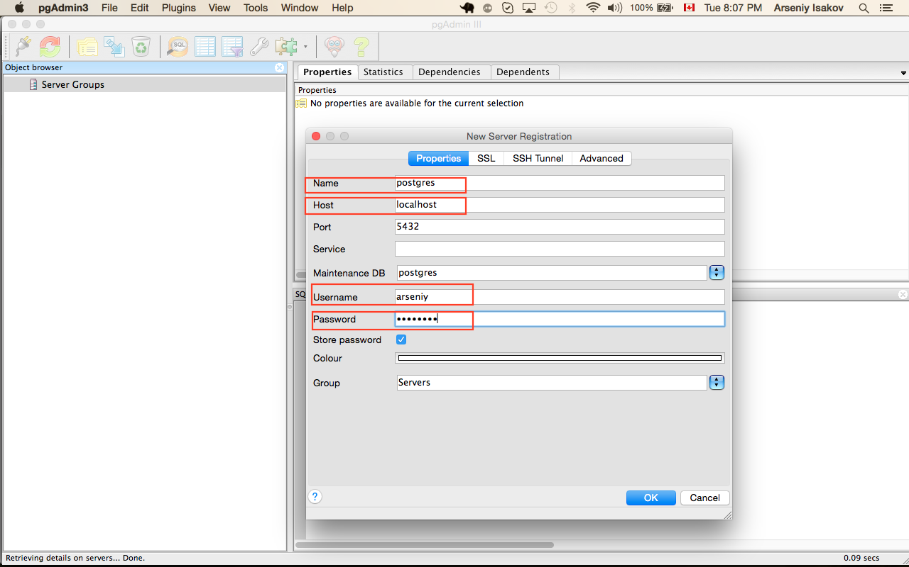

1. Create hr schema

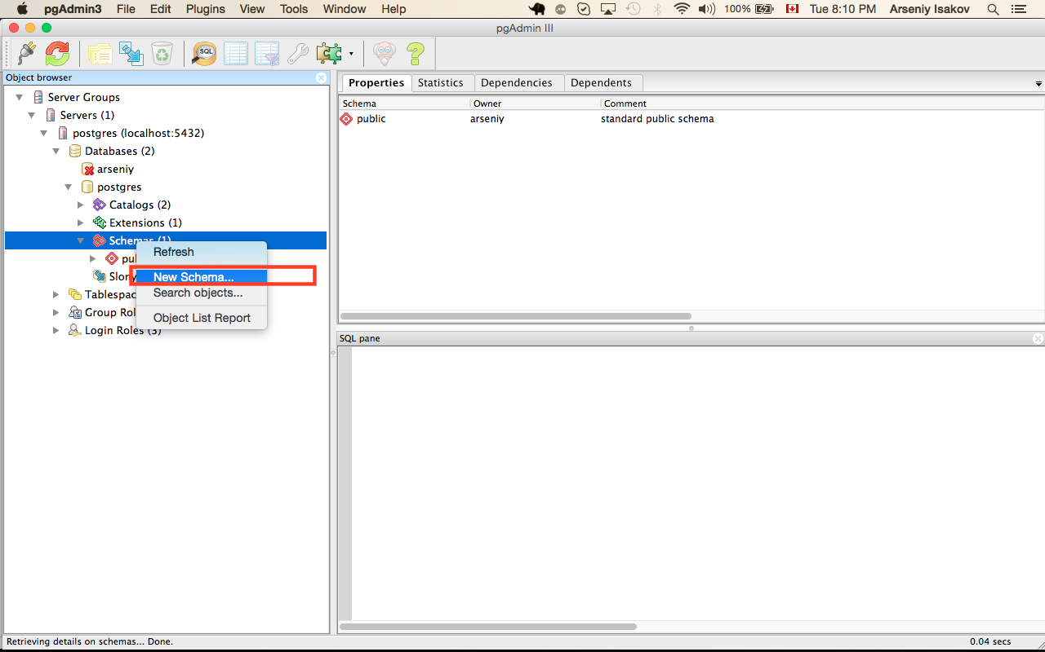

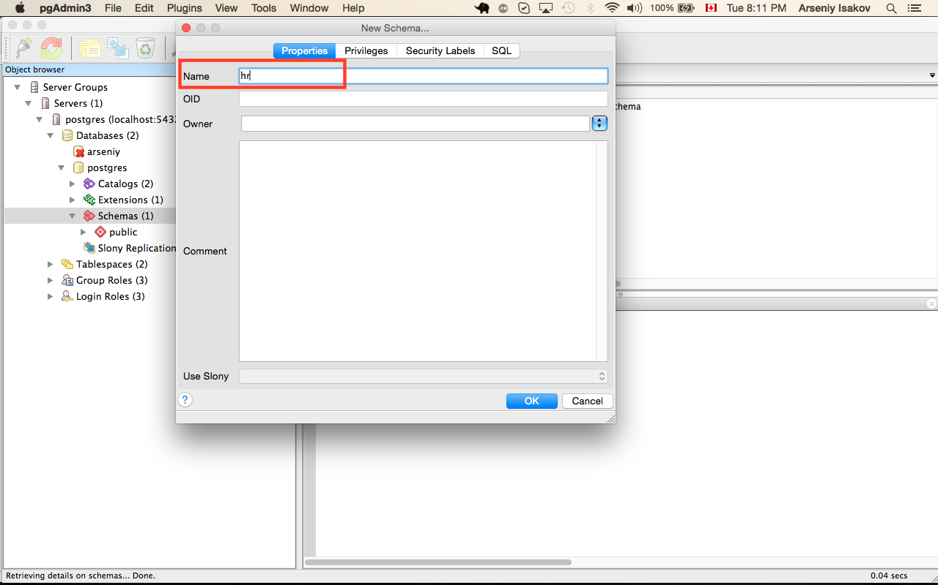

1. Grant access to new schema. To do that run sql tool

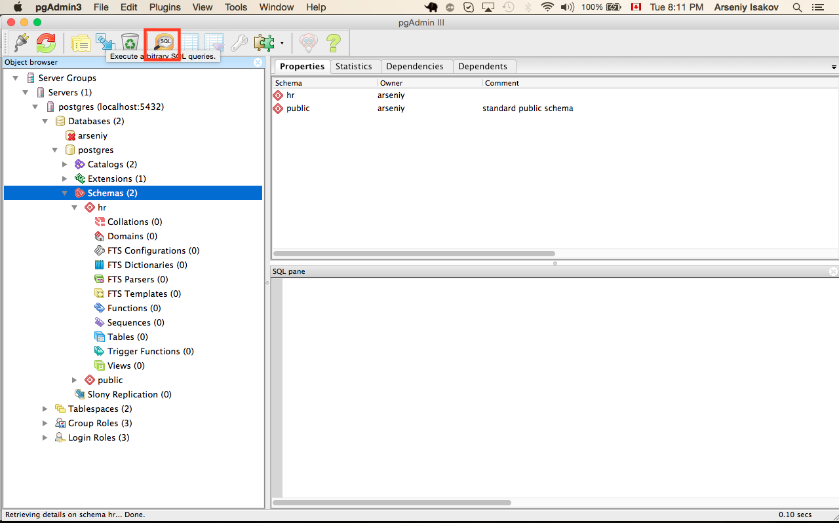

And execute query:

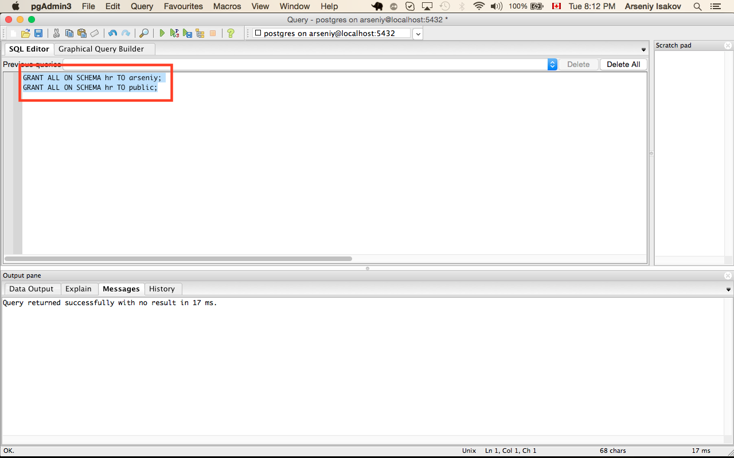

# Installation of application server

1. Download glassfish4 (full platform) from <https://glassfish.java.net/download.html>.

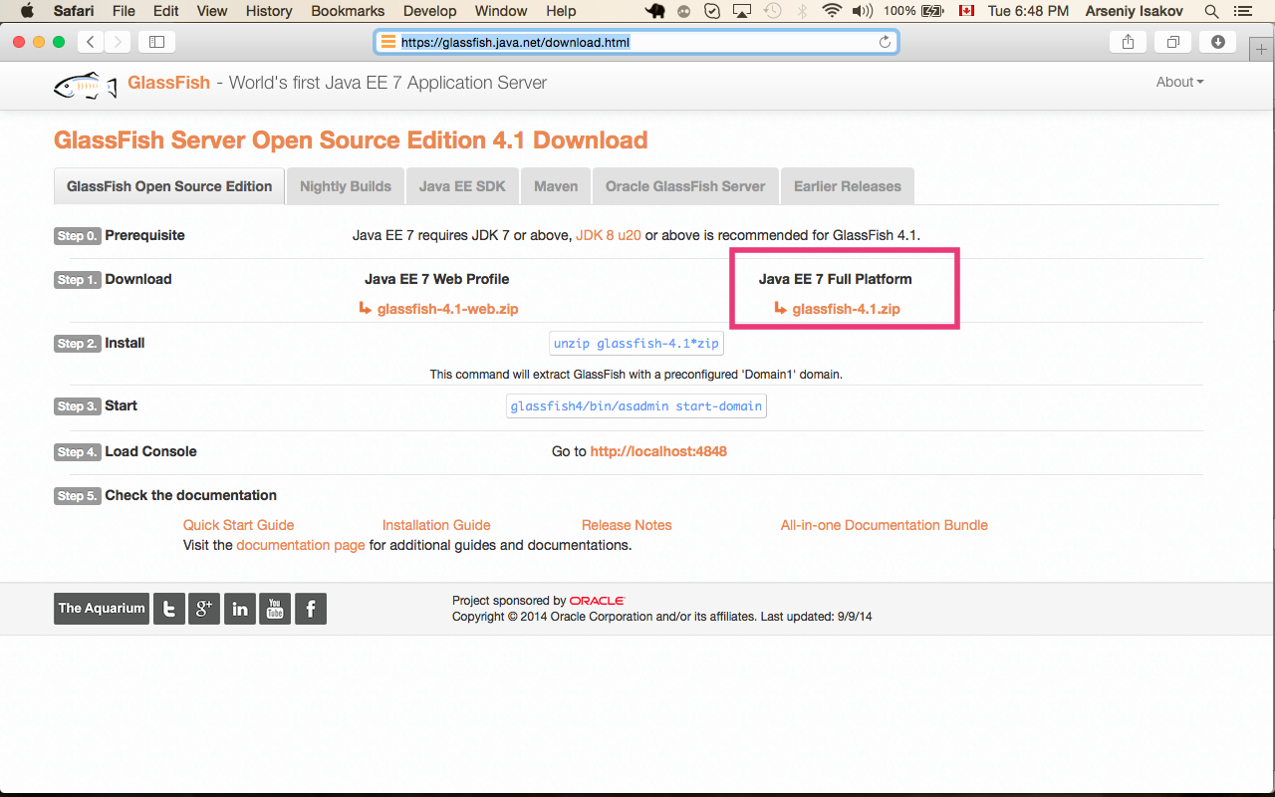

1. Download Hibernate from <http://hibernate.org/orm/downloads/>

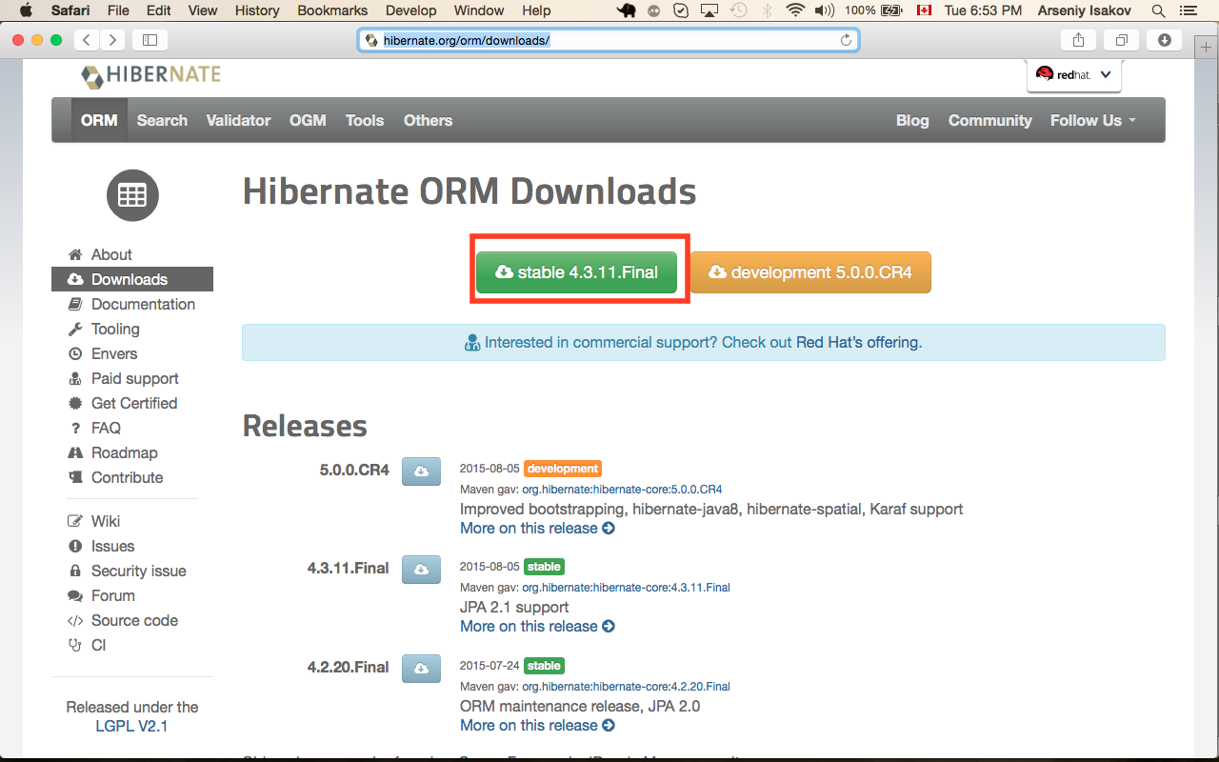

1. Download postgres SQL deriver from <https://jdbc.postgresql.org/download.html>

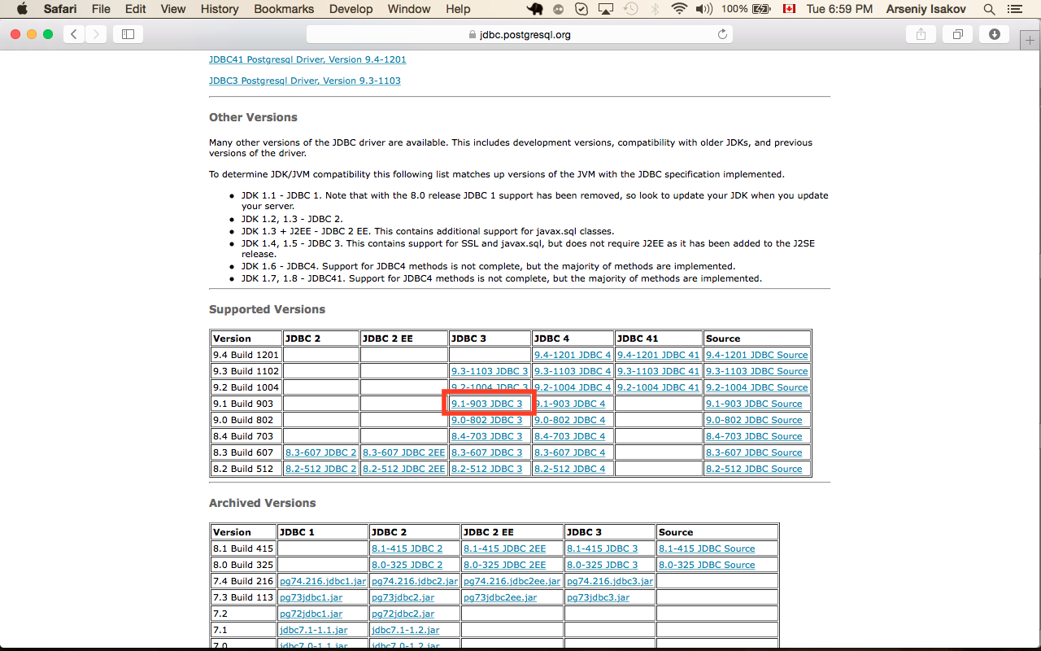

1. Extract achieve glassfish-4.1.zip
2. Copy postgres jdbc driver to <GLASSFISH_HOME>/glassfish/lib
3. Extract archive hibernate-release-4.3.11.Final.zip
4. Copy hibernate to <GLASSFISH_HOME>/glassfish/lib

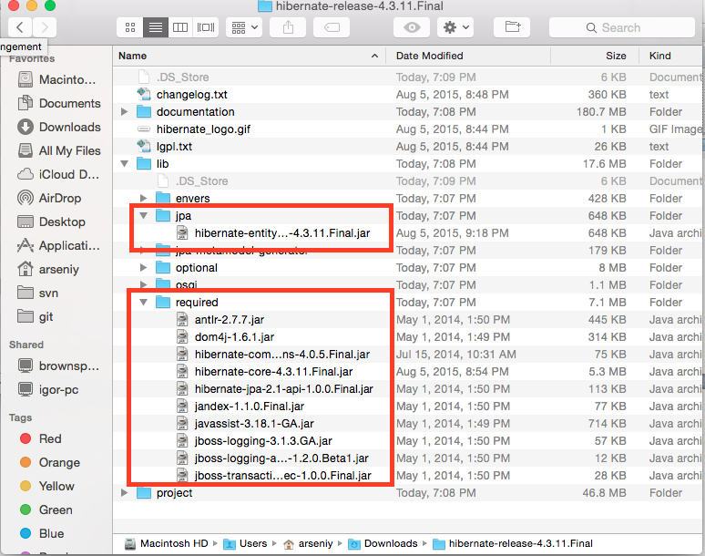

1. From command line execute following command to start server ~/glassfish4/bin/asadmin start-domain --verbose domain1

# Connection pool configuration

1. Run application server admin console in your browser (<http://localhost:4848/common/index.jsf>)
2. Select “JDBC Connection Pool” and press “New” button

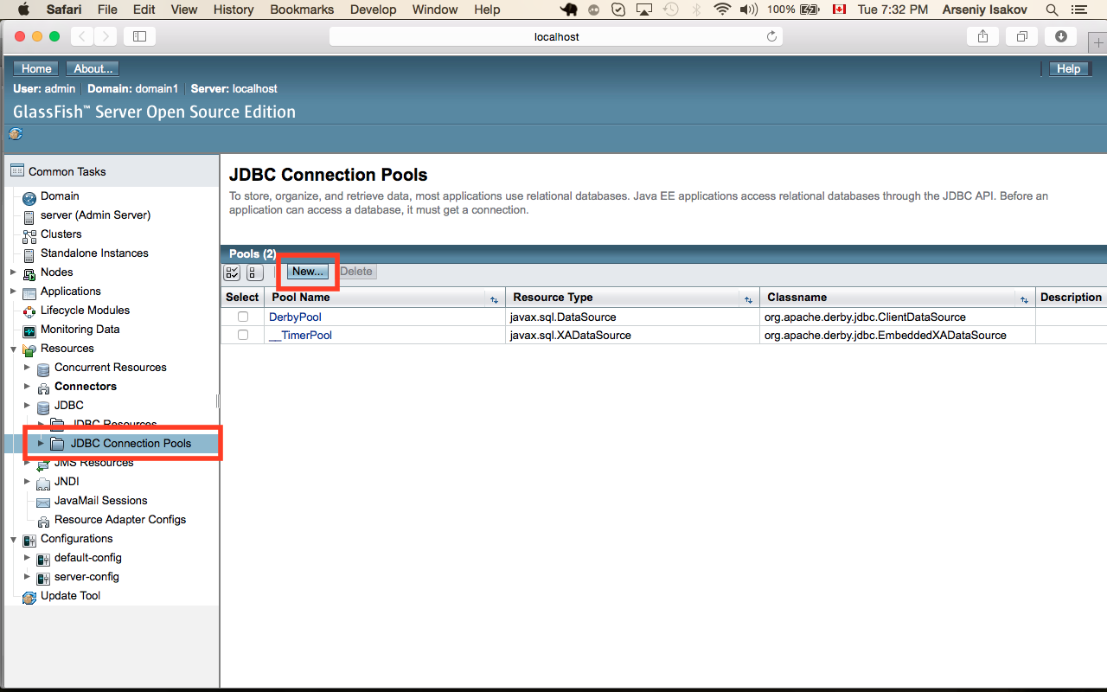

1. Populate configuration parameters and press next button

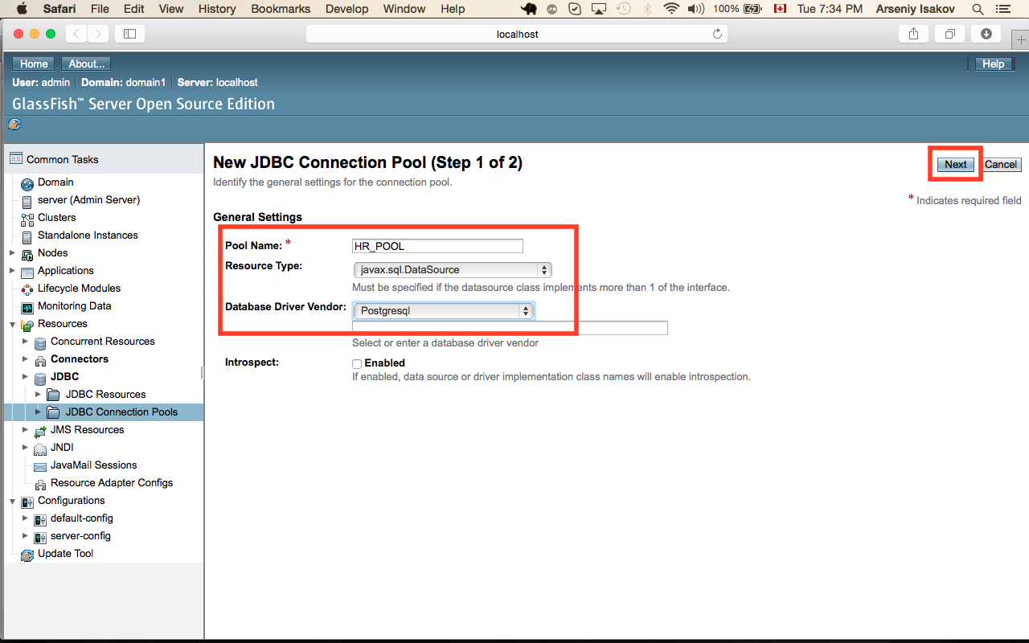

1. Enable ping to database

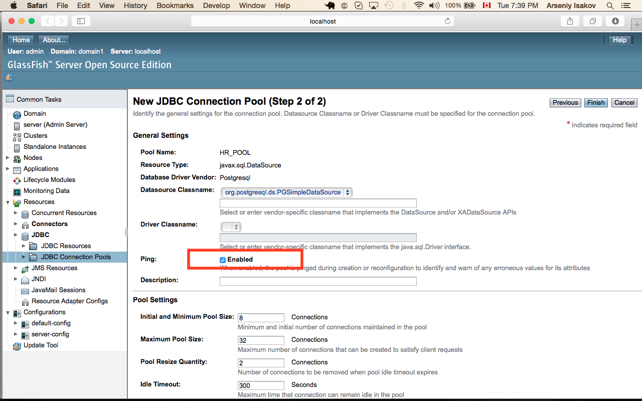

1. Populate following parameters and press “Finish” button

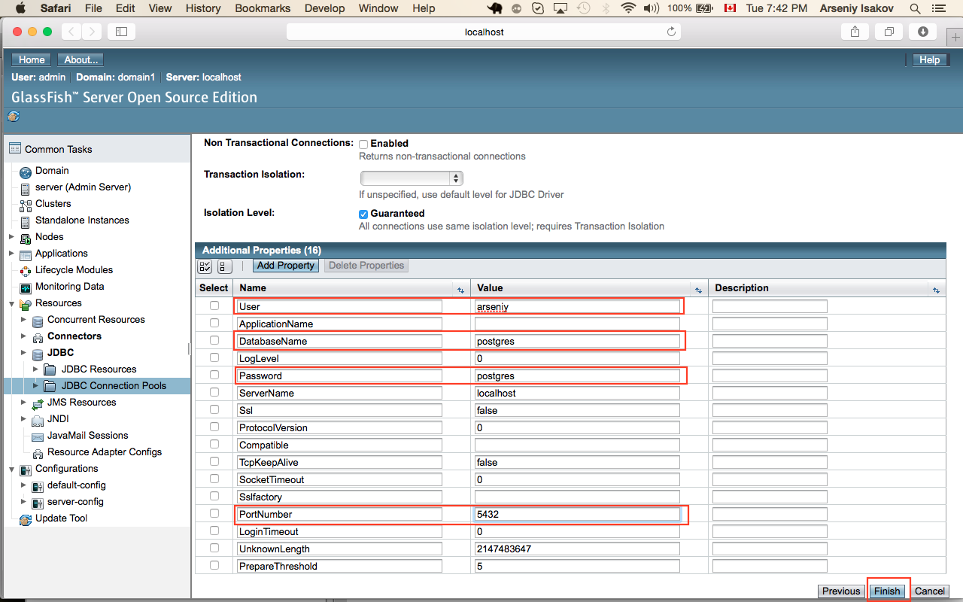

If you configured connection properly you will get following picture

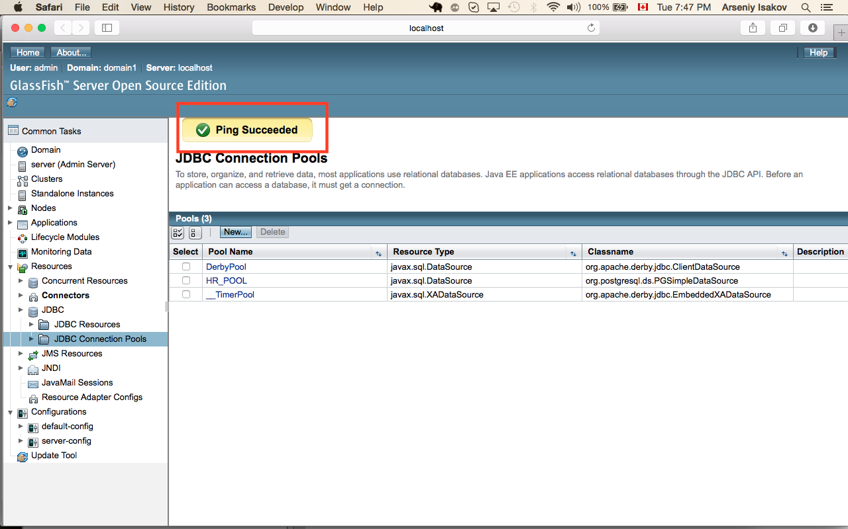

1. Select “JDBC Resources” and press “New” button

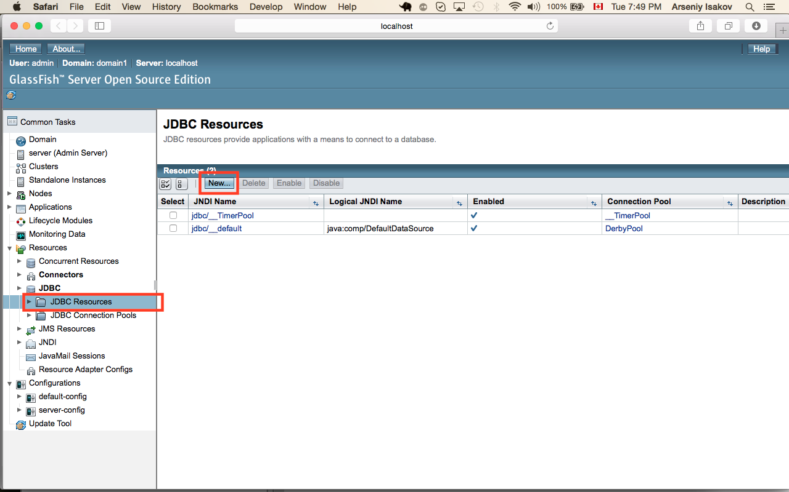

1. Enter values for “JNDI Name”, “Pool Name” and press “ok” button

